Test 1- (AUTHENTICATION TESTS)

The Basic checks include, UserName character check

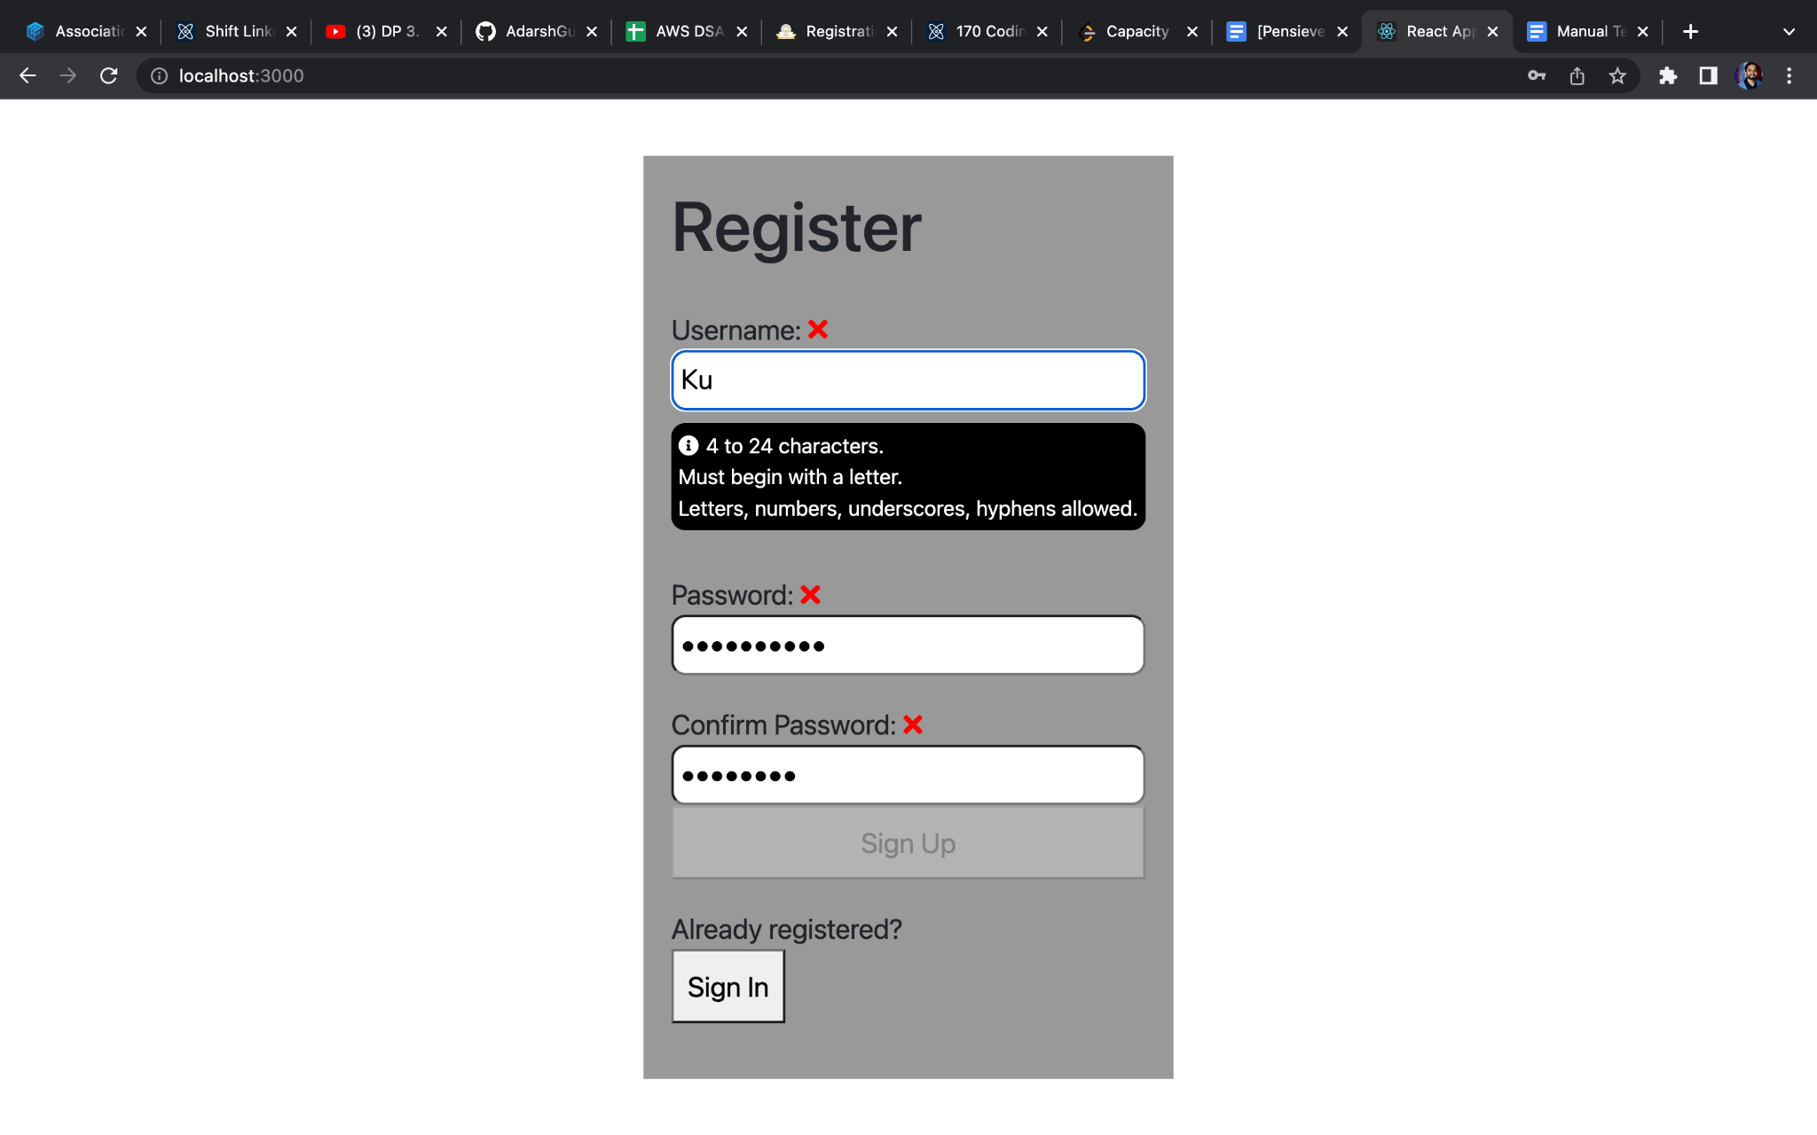

Password character Check

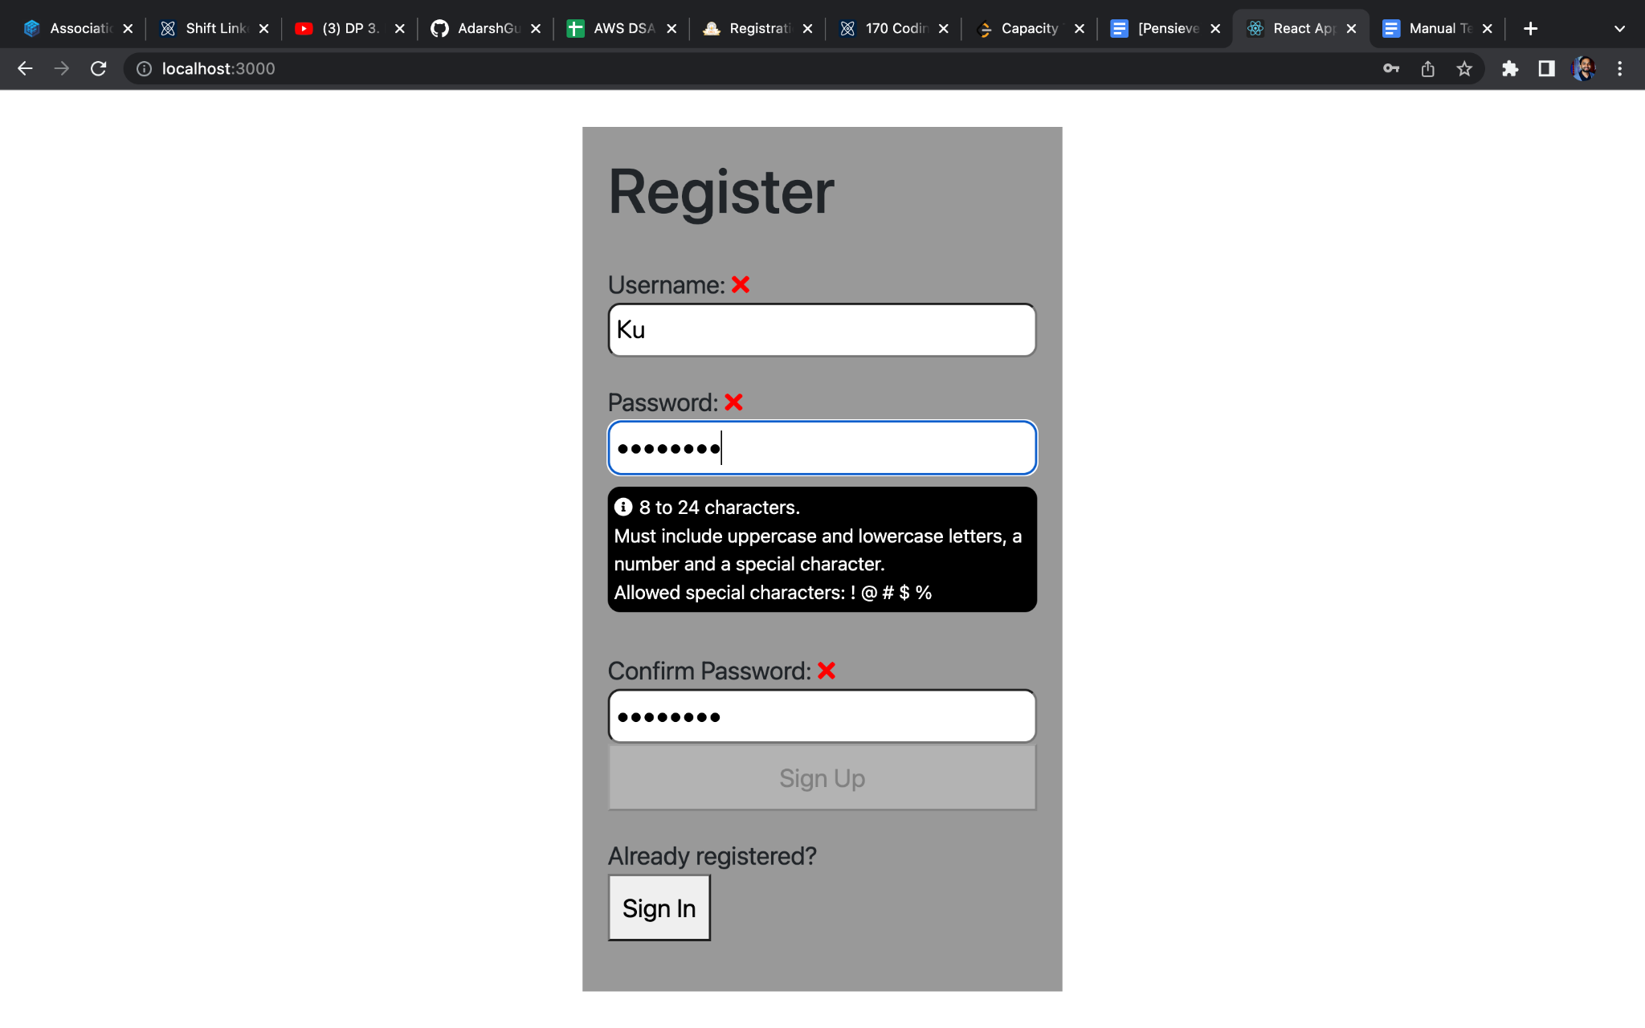

Confirm Password Character Check

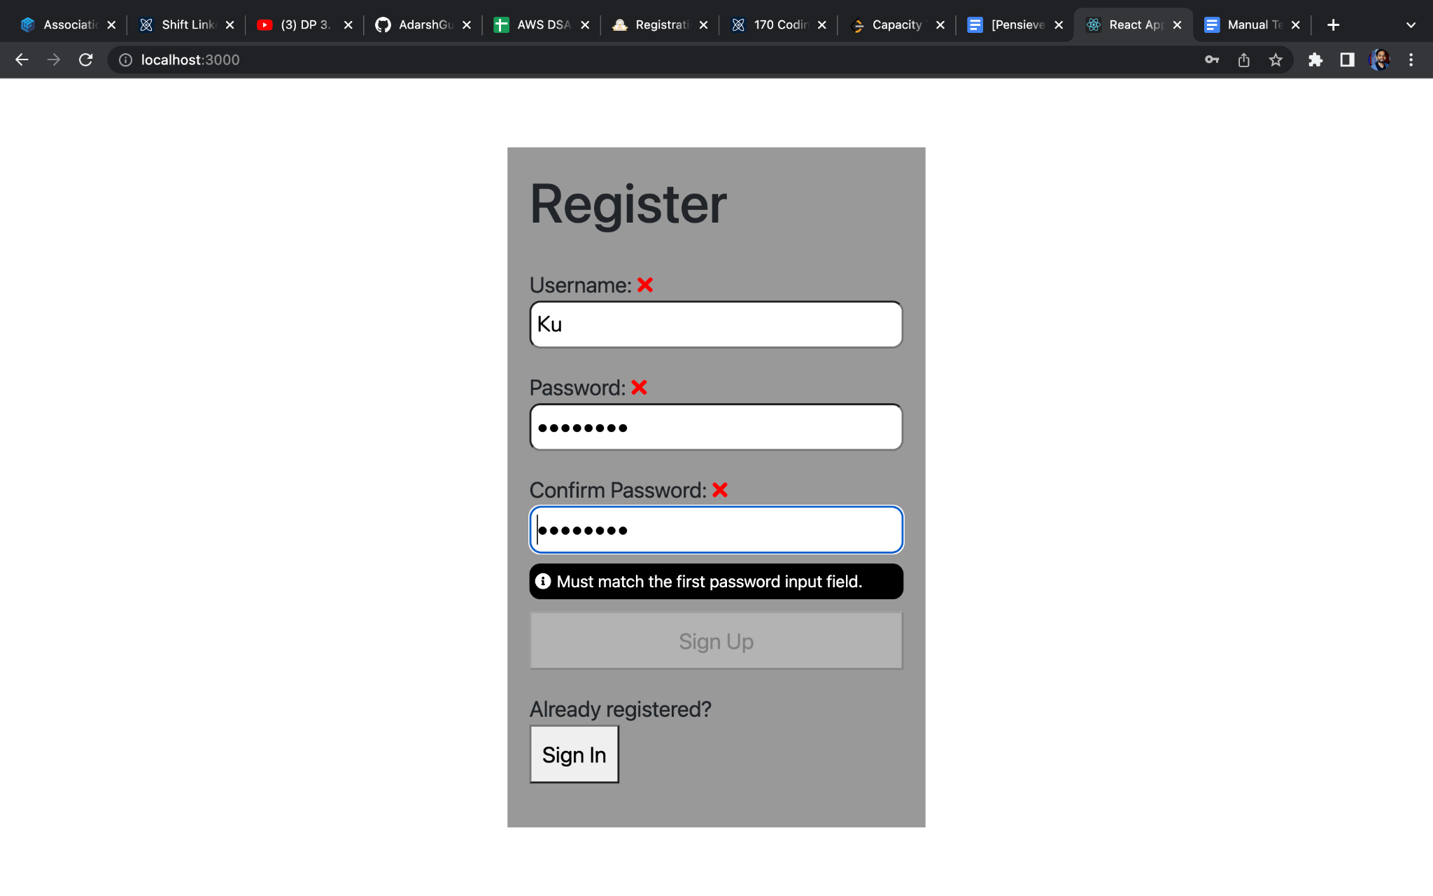

Suppose I have stored a userName - KunalTiwa and password - KunalTiwary@43. If I again register using the same name, I get a “username taken” error(As shown below).

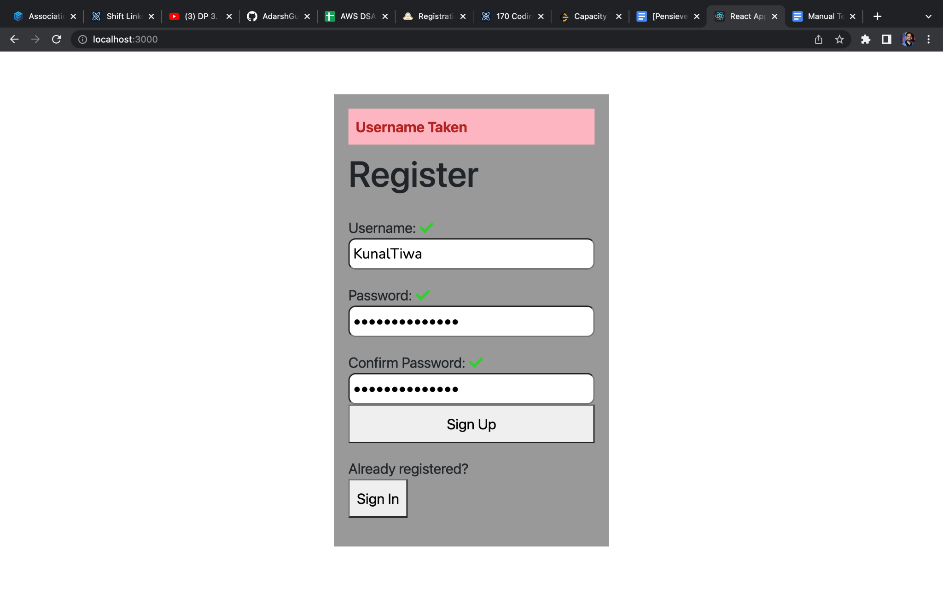

When the password entered is Invalid

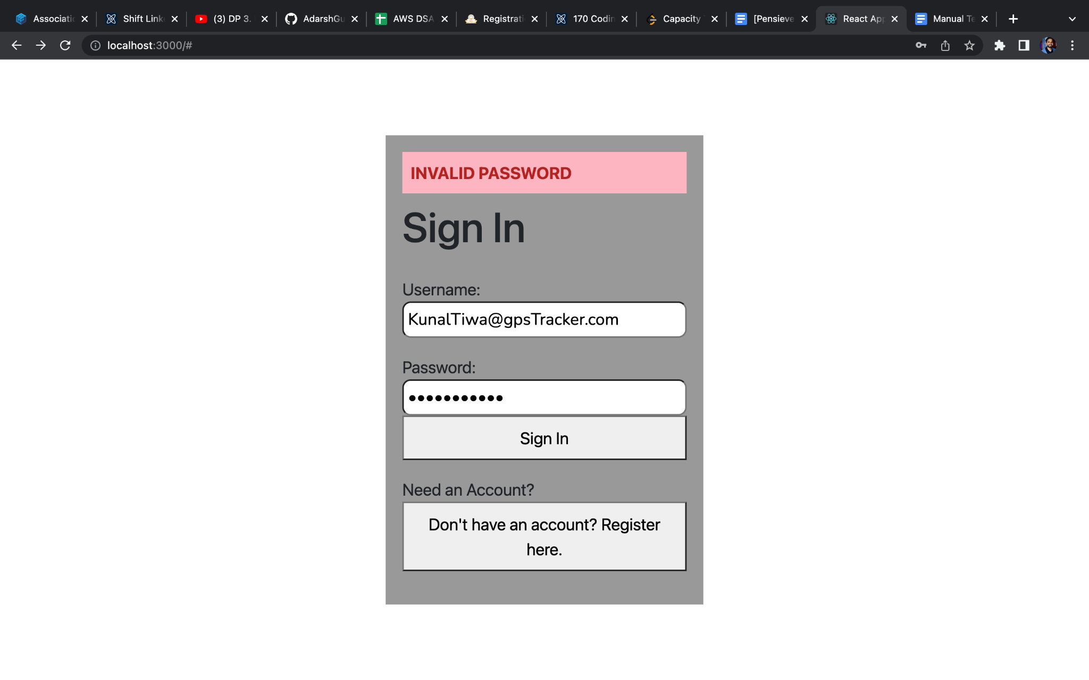

When the password entered is Invalid

